GL 317

GL 317 is a 0.42 M☉, M3V star1. Based on 57 RV HIRES measurements obtained between 2000 and 2020, the CL survey reported a GP (GL 317b) signal with a period of 722.3 ± 0.4 days, a minimum mass of 1.852 ± 0.037 MJup and an eccentricity of 0.098 ± 0.016 as well as a LPGP (GL 317c) signal with a period of , a minimum mass of MJup and an eccentricity of .

In the present study, in addition to the CL survey’s dataset, 144 RV HARPS measurements obtained between 2010 and 2018 were used. DPASS and MCMC (1000 walkers and 400000 iterations) were used to fit the data. The properties found for the two planets reported in the CL survey were within the error bars associated with the values found in the present analysis. However, the poor sampling of the Hir94 data does not constrain the period well.

To explore the range of possible values, the semi-major axis was fixed to different values and the data fitted with DPASS. *a* up to 14.5 au do not significantly change the rms of the residuals (5.8 m/s against 4.8 m/s with *a* left free). In this case (referred to as constrained *a*), the minimum mass is 1.75 MJup and the high eccentricity is 0.7. As the RV curve of GL 317c covers a maximum and a minimum, the stellar offset is well constrained and changing it will not change the possible solutions beyond those found with the constrained semi-major axis.

The fits are shown in Fig 1, and the corner plot in Fig 2, and the results summarized in Table 1.

Conclusion: The properties found in the CL survey for GL 317c are not confirmed. New data are needed to improve the long-term coverage and sampling of the RV variations and further constrain the orbital properties of GL 317c.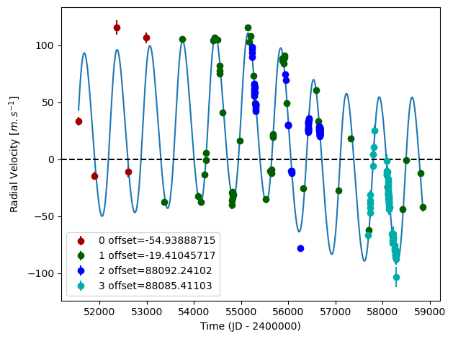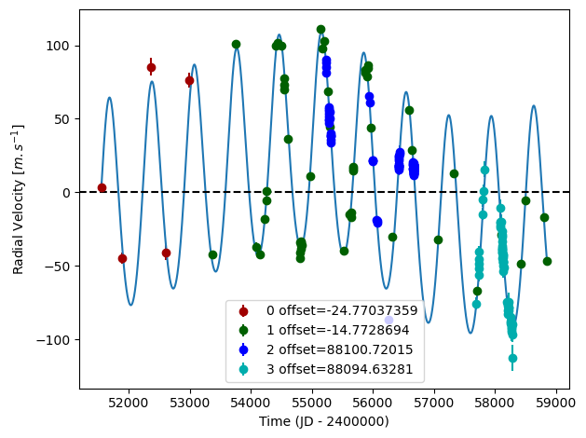

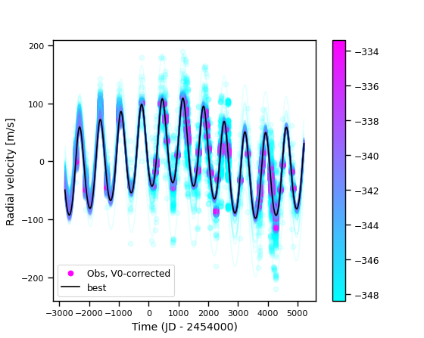

Figure 1: Left: fit of the GL 317 RV with DPASS. Red - Hir94, green - Hir04, blue - H03, cyan - H15. The blue curve shows the best fit. Middle: fit of the GL 317 RV with DPASS, with the minimum *a* fixed at 14.5 au. The points are the same as on the left. The blue curve shows the best fit. Right: fit of the GL 317 RV using MCMC. The black curve shows the best fit. The colorbar corresponds to the log-likelihood of the fits.

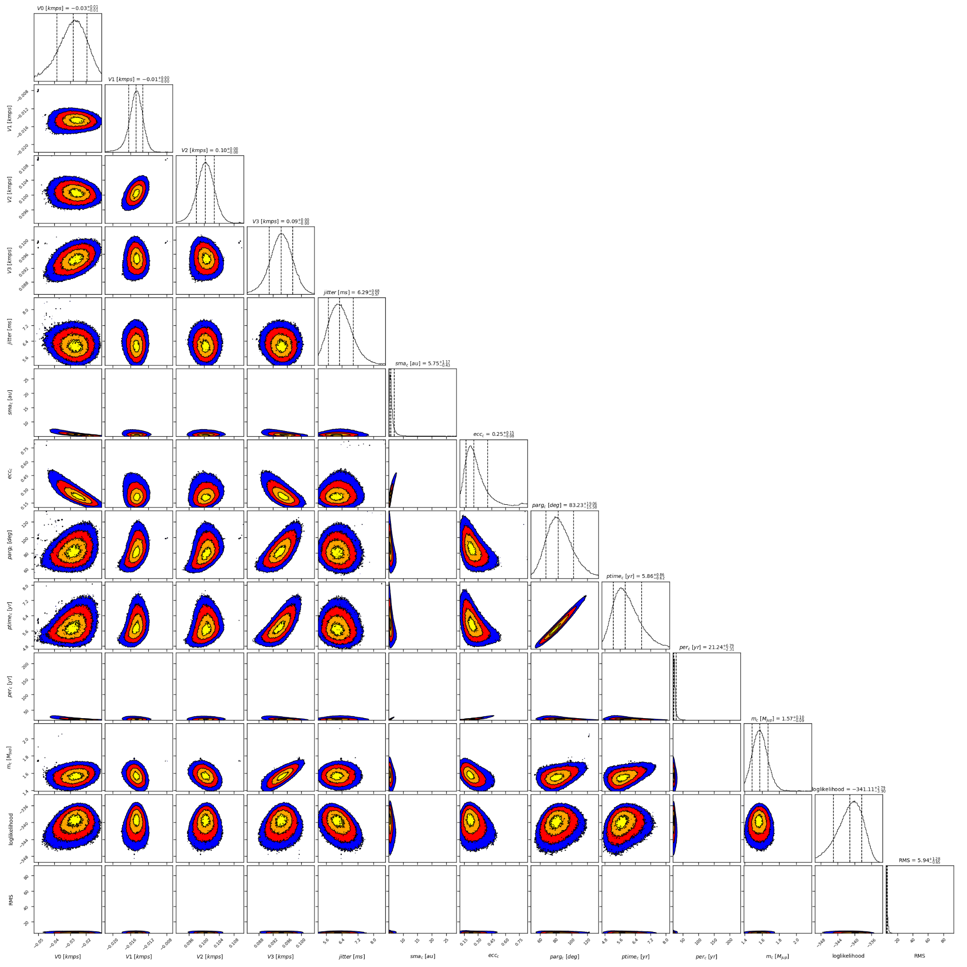

Figure 2: Corner plot of posteriors for the two-planets model MCMC fit of GL 317 RV data.

| Parameter | Priors | | | Posteriors | | | CL survey |
| --- | --- | --- | --- | --- | --- | --- | --- |
|  | DPASS | | MCMC | DPASS | | MCMC |  |
|  | Free priors | Constrained *a* | Free priors | Free priors | Constrained *a* | Free priors |  |
| *a* (au) | b: [0,100]  c: [0,100] | b: [0,100]  c: up to 14.5 | b: [0.5,2]  c: [3,100] | b = 1.15  c = 5.5 | b = 1.15  c = 14.5 | b = 1.15 ± 0.01  c = 5.4 – 7.5 | b = 1.1799 ± 0.0076  c = |
| Msin(i) (MJup) | b: [0,100]  c: [0,100] | b: [0,100]  c: [0,100] | b: [0.1,10]  c: [1,20] | b = 1.79  c = 1.6 | b = 1.79  c = 1.75 | b = 1.79 ± 0.03  c = 1.6 ± 0.1 | b = 1.852 ± 0.037  c = |
| Eccentricity | b: [0,0.95]  c: [0,0.95] | b: [0,0.95]  c: [0,0.95] | b: [0,0.9]  c: [0,0.95] | b = 0.08  c = 0.22 | b = 0.08  c = 0.7 | b =  c = 0.18 – 0.45 | b = 0.098 ± 0.016  c = |
| Instrumentals offsets (km/s) | [-60,60] | [-60,60] | Hir94: [-1,1]  Hir04: [-1,1]  H03: [87,89]  H15: [87,89] | Hir94: -0.025  Hir04: -0.015  H03: 88.101  H15: 88.095 | Hir94: -0.055  Hir04: -0.020  H03: 88.092  H15: 88.085 | Hir94:  Hir04: -0.015 ± 0.002  H03:  H15: |  |
| Stellar jitter (m/s) | [0,40] | [0,40] | [0,20] | 5.6 | 6.9 |  |  |
| Argument of periastron (°) | b: [0,360]  c: [0,360] | b: [0,360]  c: [0,360] | b: [0,360]  c: [0,360] | b = 348  c = 83 | b = 293  c = 66 | b =  c = 68 – 102 |  |
| Phase | b: [0,1]  c: [0,1] | b: [0,1]  c: [0,1] | b: [0,1]  c: [0,1] | b = 0.31  c = 0.64 | b = 0.2  c = 0.8 | b = 0.62 ± 0.03  c = 0.17 – 0.34 |  |

Table 1: GL 317. Summary of priors and output obtained with DPASS and MCMC, compared to the properties reported by the CL Survey.

References

1. Anglada-Escudé, G. et al. Astrometry and Radial Velocities of the Planet Host M Dwarf GJ 317: New Trigonometric Distance, Metallicity, and Upper Limit to the Mass of GJ 317b. *Astrophys. J.* 746, 37 (2012).